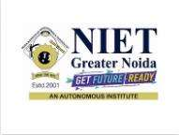

**MINI PROJECT USING OPEN TECHNOLOGY**

**(ACSE-0459)**

2101330109003

**Affiliated to Dr. A.P.J Abdul Kalam Technical University, Uttar Pradesh**

**Ms. RITIKA & Ms. SURBHI PURWA Name: Garv Kumar**

**Roll No: 2101330109003**

**Submitted To: Submitted By:**

**(IV-SEMSTER)**

**LAB FILE**

**ON**

**Session (2021 – 2022)**

COMPUTER SCIENCE & ENGINEERING

NOIDA INSTITUTE OF ENGINEERING AND TECHNOLOGY

GREATER NOIDA-201306

(An Autonomous Institute)

College of Computer Science & Engineering

CSE-IV-D2